Spring MVC CRUD javaBased:

Previous mvc crud is xml based mean that project have two xml file web.xml and spring-servlet.xml

Web.xml for Dispathcher servlet

Spring-servlet.xml for viewResolver and database connectivity

So in java based crud we can not use .xml file we use java class

In javabased crud we create one package name as utility and in that we create 2 class

Appconfig.class and Initialiser.class

And remaining crud is same as previous.

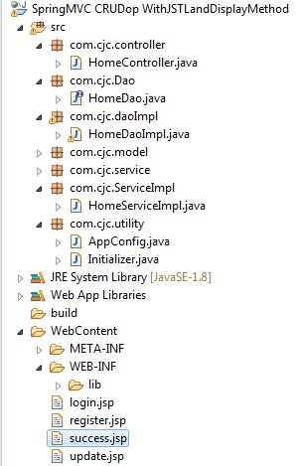

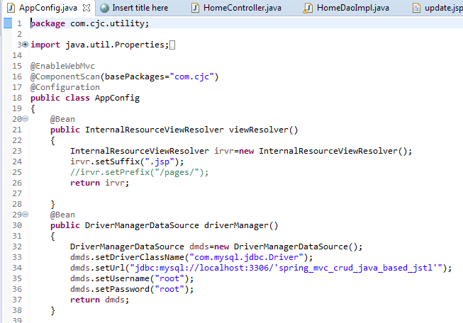

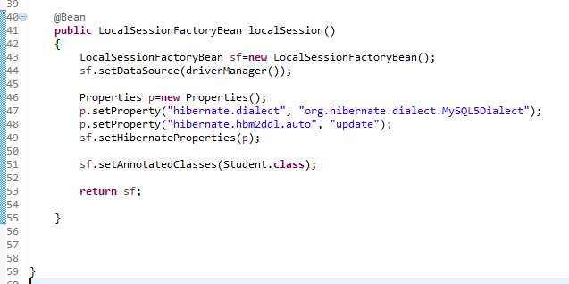

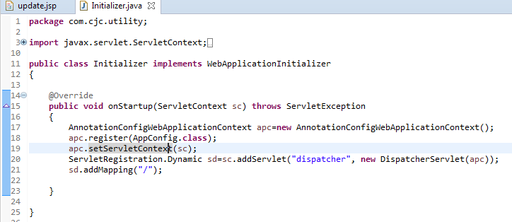

o/p is also same as previous crud o/p;

Success page by using jstl:

<%@taglib uri=*"http://java.sun.com/jsp/jstl/core"* prefix=*"c"*%>

<%@page import=*"com.cjc.model.Student"*%>

<%@page import=*"java.util.List"*%>

<%@ page language=*"java"* contentType=*"text/html; charset=ISO-8859-1"*

pageEncoding=*"ISO-8859-1"*%>

<!DOCTYPE html PUBLIC "-//W3C//DTD HTML 4.01 Transitional//EN" "http://www.w3.org/TR/html4/loose.dtd">

<html>

<head>

<meta http-equiv=*"Content-Type"* content=*"text/html; charset=ISO-8859-1"*>

<title>Insert title here</title>

<h2 align=*"center"*>Student Data</h2>

<script type=*"text/javascript"*>

**function** deleteRecord()

{

alert("Delete");

document.myform.action="delete";

document.myform.submit();

}

**function** addRecord()

{

alert("Add");

document.myform.action="add";

document.myform.submit();

}

**function** updateRecord()

{

alert("Update");

document.myform.action="edit";

document.myform.submit();

}

</script>

</head>

<body>

<form name=*"myform"*>

<table border=*"1"* align=*"center"*>

<tr>

<th>Select</th>

<th>Id</th>

<th>Username</th>

<th>Password</th>

<th>Name</th>

<th>MobileNo</th>

</tr>

<c:forEach items=*"*${data}*"* var=*"stu"*>

<tr>

<td><input type=*"radio"* name=*"id"* value=*"*<c:out value="${stu.id}"></c:out>*"*></td>

<td><c:out value=*"*${stu.id}*"*></c:out></td>

<td><c:out value=*"*${stu.uname}*"*></c:out></td>

<td><c:out value=*"*${stu.pass}*"*></c:out></td>

<td><c:out value=*"*${stu.name}*"*></c:out></td>

<td><c:out value=*"*${stu.mobileNo}*"*></c:out></td>

</tr>

</c:forEach>

<tr>

<td><input type=*"button"* value=*"Delete"* onclick="deleteRecord()"></td>

<td><input type=*"button"* value=*"Add"* onclick="addRecord()"></td>

<td><input type=*"button"* value=*"Update"* onclick="updateRecord()"></td>

</tr>

</table>

</form>

</body>

</html>